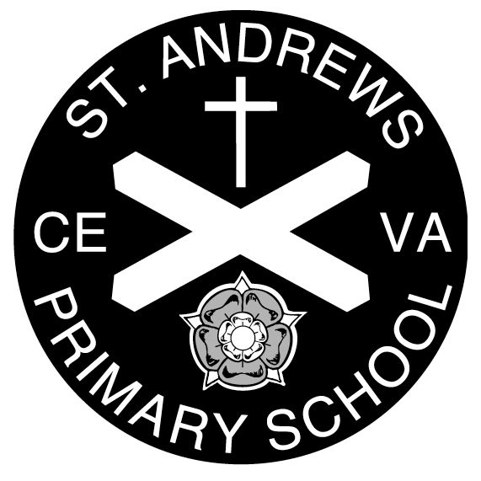
Please complete and return this form to enquiries@standrewsceva.uk if your child receives a positive Covid-19 test result over the weekend.

Child’s Name …………………………………………………………………………..

Year………………………………. Class ..………………………………………….

Date symptoms started: ………………………………………

What are their symptoms? (Please tick)
- Temperature
- New persistent cough
- Loss of taste or smell

Date positive Covid test was taken ………………………………………

Preferred contact number ………………………………………….

Second contact number …………………………………………..

